THE BUZZzzzzzzzzz 
November CLUB MEETING
ATTENTION MEETING DATE CHANGED DUE TO VETERANS DAY HOLIDAY
Reminder October meeting is next Tuesday, NOVEMBER 12
7:00 PM
Beulah Recreation Center
6901 Hopkins Road
Come about 6:30 to socialize and network before the meeting.
Door prizes are only available to those in attendance so “you got to be in it to win it”.
It’s time to get back to face to face meetings so we can help each other to be more sustainable beekeepers.


Beekeeping Study Group Meeting
Monday
November 18th
7:00 PM
Beulah Recreation Center
6901 Hopkins Road

Spring Beekeeping Class

4-week session

9am-4pm
January 18th
February 1st
February 15th
March 1st

First class is on January 18th. Class information and sign up coming soon!!!!!

November
To-Do List

*Attend bee club meetings

The month of November is nearly "last call" for beekeeping for this year. We can expect to have several good days to complete all bee-yard projects. It is not panic time, but it is must-do time.

THE HIVES
*Plan to visit each hive one more time this year.

• Make your final hive inspections. Try to move the honey frames to the upper hive body and the "outer" positions in the lower hive body. Concentrate the brood to center of the lower box.
• Combine any weak hives with stronger hives (remove the weak queens & use newspaper to combine hives).
• Remove any remnants of any mite treatments that were used this fall.
• Continue checking the hive weights by lifting the backsides. Hives will need to contain enough honey or emergency feed to maintain the population. Any hive that is light should be fed a heavy sugar syrup (2:1 ratio).
- Start preparing emergency / solid food for winter. Sugar blocks or candy boards
• Add entrance reducers or place mouse guards over the hive entrances, also be prepared to provide upper entrance/ventilation for the hive.

PHOTO OF THE MONTH:
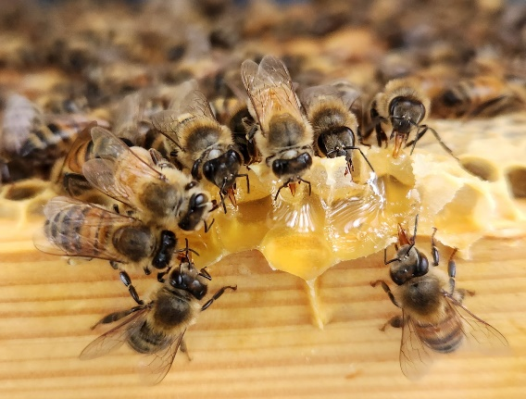
Photo by Vikki Davis
Want to display your photo? send it to: srdpottery@gmail.com
*Original photos only and please state for the Rockwood Newsletter in subject line.

IMPORTANT LINKS
Club website: https://rockwoodbeekeepers.com/
2024 Complete Club Calendar: https://rockwoodbeekeepers.com/calendar/
Club email: rockwood.beekeepers@gmail.com
Club Facebook: https://www.facebook.com/RockwoodParkBackyardBeekeepers


Inside…..
Monthy Meeting- 11/12 TUESDAY
Study Group Meeting 11/18
Spring Class Dates
November TO DO The HIVE!!!
Photo of the Month
Links
Check out the Newsletter for the details…… link below

